

DEPARTMENT OF INFORMATION TECHNOLOGY
SCHOOL OF COMPUTING AND INFORMATICS

LOGBOOK: MOBILE APPLICATION DEVELOPMENT
UNIT CODE: BIT4107
NAME: YUSUF ANEMBA
REGNO: BIT/2020/90745
PROJECT NAME: MASENO WISDOM HOSTEL MANAGEMENT SYSTEM

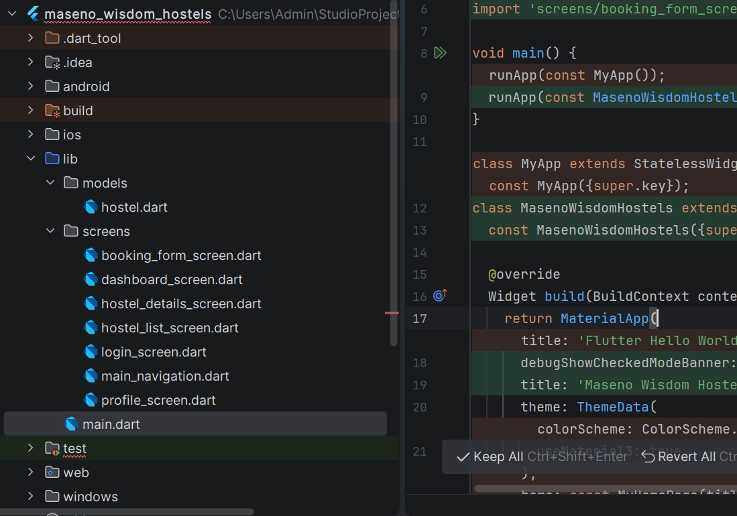
Figure 1.1 screenshot of project development in android studio
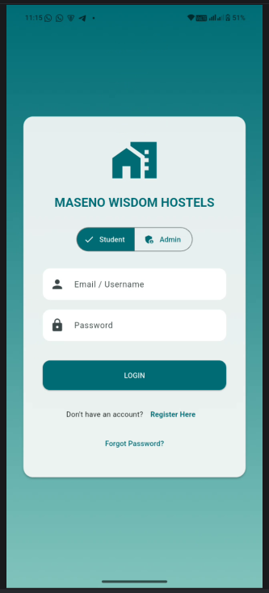
Figure 1.2 login screen for the hostels mobile application with an option for adding new users, and an admin panel for the management.
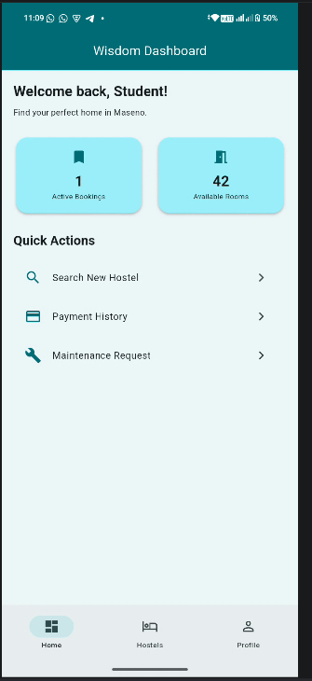
Figure 1.3 Each tenant/student gets their own login panel to view their details and request anything from the management.

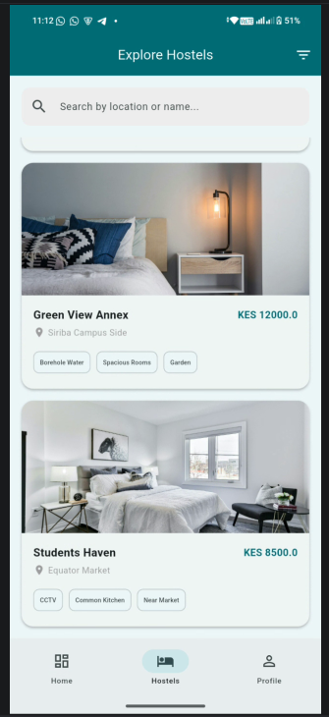
Figure 1.4 while booking, a pictorial and some room details are provided to the tenant to view and inspect the rooms before actually paying for them.
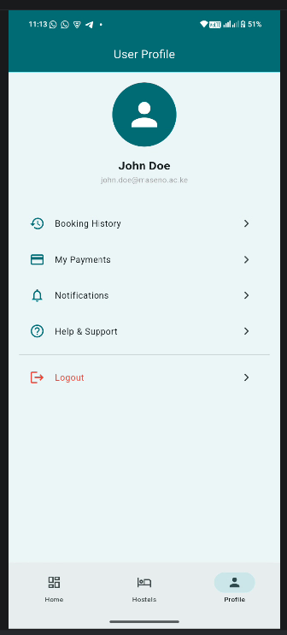
Figure 1.5 upon successful onboarding, each tenants have their accounts and their details as per the rooms they are staying in.

TOOLS AND TECHNOLOGIES USED
For the development of the JAMHURI STUDENT MANAGENT APP, I used the following tools,
- Flutter
- Dart
- Figma
- Android studio
- Android emulator/ my android phone

